Purpose: To find the volume of a Hershey Kiss using a variety of methods.

Step 1:
You will be divided into groups of three:
Obtain a Hershey Kiss from your teacher.
- Pour water into the graduated cylinder and record the volume of water.
- Wrap the Hershey Kiss in saran wrap and suspend it into the graduated cylinder, immersing it in the water.
- Record the volume of water, and measure the displacement (i.e. the difference in volume prior to immersion and post-immersion).

Step 2:
Determine how to slice the Hershey Kiss to find its volume
- Does the item have horizontal or vertical symmetry? If so, the volume can be found by revolving a cross-section about a horizontal or vertical line.
- Does the item have a flat bottom? If so, the volume can be found by using the “volume by cross-sections” method.
Indicate method (axis of rotation, disk/washer, or volume by cross-sections) on data sheet.

Step 3:
Prepare to trace a cross-section of the item.
- An item with vertical or horizontal symmetry may be sliced along the line of symmetry. Sometimes it is possible to trace the item without slicing, but this can be difficult. Before slicing, consult with Mrs. Cowley to confirm procedure. Leave the foil or wrapping on the item to protect it (as much as possible) so you can eat it later. ☺
- An item with a flat bottom need not be sliced.

Step 4:
On graph paper, align cross-section of the item or the flat bottom of the item along the positive $x$-axis and trace its outline. Be precise, keeping the pencil as close to it as possible to get an accurate outline.
Collect at least 10 data points from your graph and record them in a table on your graph paper. Note: The scale of the graph paper is ¼” per block.

Step 5:
Find the equation of your function using the graphing calculator.
Enter data into the stat, edit menu. Plot the data in a scatter plot. Calculate the regression equation (quadreg, cubicreg, quartreg, etc.), choosing the one with the best correlation coefficient (r) and which best fits the scatter plot when graphed. (You will need to make sure that the diagnostics are enabled on your calculator to get the value of r). When recording this function, do not round values in the equation. This will yield a more accurate volume.

Step 6:
Write an integral to find the volume of the item
Record your calculations, including the complete integral with limits of integration.
Note: this volume will be in cubic inches.

Step 7:
Submit Results. Include Data sheet and graph paper.

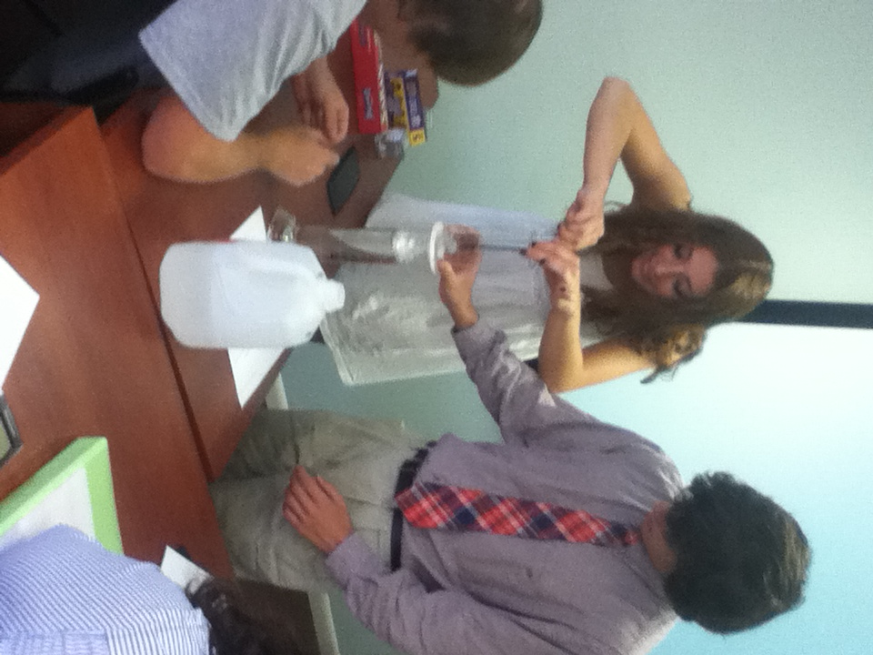
Students carefully immerse a Hershey Kiss in water to measure the displacement of water. This is the first phase of the group activity where students find the volume of a Hershey Kiss using three different methods.

Hershey Kiss Activity
Data Sheet: Names ________________________
________________________
________________________

Step 1: Method (check one. If using disk/washer, indicate axis of rotation)

Item | Water volume |  | Disk/washer | Axis of rotation | Volume by cross-sections
Hershey Kiss | Before | After

Step 3: Graph and data points (attach graph paper)

x | y

Step 4: Equation

Step 5: Integrand, limits, integration and volume

