Derivative Card Match
Graphing activity instructions:
Each group is given a set of 32 cards that contain 8 sets. Each set includes:
- The graph of a function
- The description of the function
- The graph of the derivative of the function, and
- The description of the derivative of the function.

The goal is to identify the 8 sets and record the answers on the sheet provided. (Your group will have either function graphs 1-8 or 9-16). Use the knowledge you have gained about the first derivative, and your knowledge about graphing functions to complete the exercise.

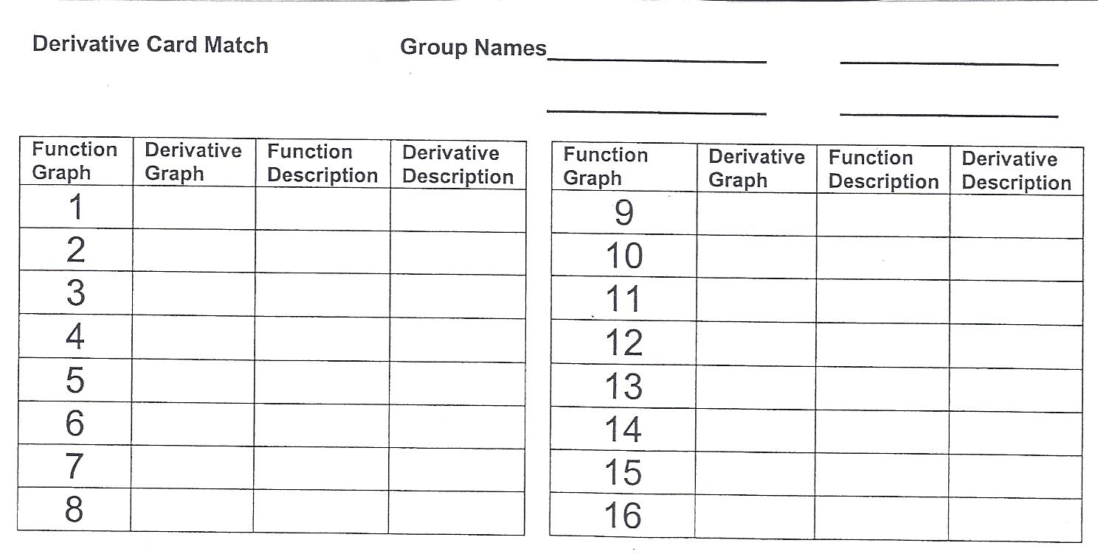
To finalize the group activity, each group will be asked to present, orally, their approach to the task of matching the 32 cards. One person from each group will be randomly selected to present for the group. The presentation may not exceed 3 minutes, yet it should be descriptive enough that someone not familiar with the activity (but with a knowledge of calculus) would understand.
The group will select an example (at random) and prepare a PowerPoint presentation illustrating the graph, the description of the function, the graph of the derivative of the function, the description of the derivative, and then demonstrate why the four parts are a set. The PowerPoint should consist of at least five slides.
The oral presentation accounts for 30% of the grade for this activity. It will be assessed according to the following rubric:
  - Neatness and design 10 pts
  - Thoroughness and accuracy 8 pts
  - Explanation, including
    - graph of function 4 pts
    - description of function 4 pts
    - graph of derivative 4 pts
    - description of derivative 4 pts

The final grade will count as a quiz grade.

The following activity was shared by the VCTM Academy for AP Calculus, March 14 & 15, 2008

