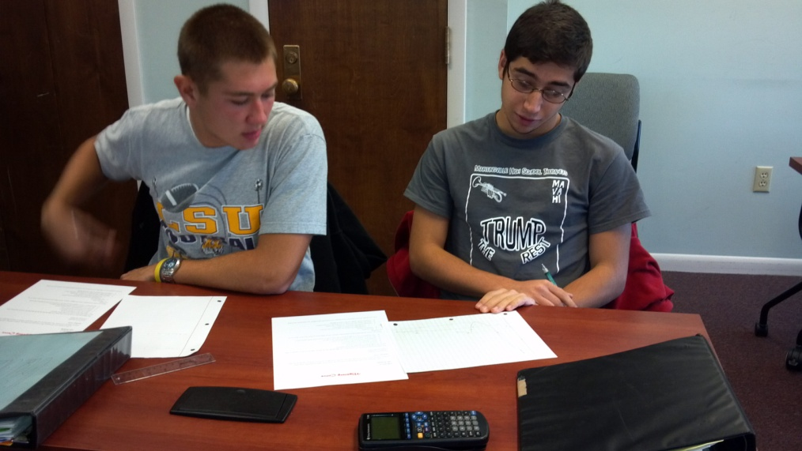
Following the study of using derivatives to analyze functions graphically, students in calculus 2 work together to find the Mystery Curve that represents a set of given conditions.

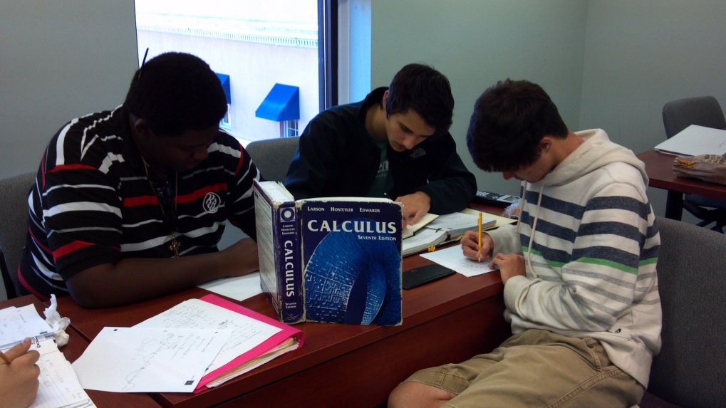
Students in calculus put their heads together to work on the weekly “FRQ” assignment.

