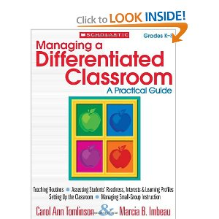
Courses Completed for Gifted Endorsement:
- Introduction to Curriculum for the Gifted:
Curriculum models and modifications for gifted students in both self-contained and inclusion classes were explored. (Fall 2009)
- Models and Strategies for Teaching the Gifted:
Theoretical and practical implications of the methods and strategies, and appropriate instructional approaches that promote academic challenge and learner independence were developed. (Summer 2011)
- Differentiated Instruction for the Gifted Learner:
Rationales for meeting the needs of gifted learners were examined, and strategies for differentiating the content, process, products, and learning environment were applied. (Fall 2011)
- Introduction to the Gifted and Talented:
A basic understanding of the characteristics and needs of gifted and talented children was provided. (Fall 2011)

