The Natives Are Limitless
In$\lim_{→3}{6x^{5}+3x^{4}+6x^{2}+255}$, the Boy Scouts of America celebrated its $\lim_{x→10}{x^{2}}$^{th} anniversary by hosting a national jamboree. I was lucky enough to go to this $\lim_{x→1}{\frac{7x-7}{x-1}}$ day long camp and festival located at Fort A.P. Hill, Virginia. Scouts from all over the world were there. Over $\lim_{x→0}{\frac{\sin{36x}}{x}}$ thousand people attended, and it was great fun. There were tons of activities for everyone to do and a very large area to explore. Rock climbing, boating, shooting, and other entertainments were available for anyone who wished to take part.
I, my Dad, and a few friends were grouped in a camp with many other scouts from different places in Virginia. The camps were spaced close together, and the organizers had made sure that people from vastly different places were near each other. To the right of our campsite was a troop from New York and to our left was a troop from Montana. This allowed us to meet many people from most of the $\lim_{x→2}{3x^{3}+6x^{2}+x}$states, including Alaska and Hawaii.
The jamboree also gave us a chance to build on our teamwork and leadership skills. While we were on our own for most of the day, we had to work together to cook meals and do some of the more important activities. Each person in the camp had a job, whether to cook, clean, or prepare food. By sticking to our individual tasks, we were able to prepare food very quickly, usually in only $\lim_{x→\frac{5π}{6}}{\sin{x}}$ hour(s).
Things went along quite nicely, until I was suddenly and inexplicably abducted by a tribe of rabid math teachers. They tied me to a $\lim_{x→2}{\frac{x^{3}-8}{x-2}}$ foot long protractor and carried me to their camp in the wilderness, where they circled around me chanting “Vertical format! Vertical format!” I was then forced to do math homework for $\lim_{x→3}{\frac{x-3}{\sqrt{x+1}-2}}$hours. As if that was not enough, I had to come up with a limit equation that equaled$\lim_{x→-3}{\frac{x^{2}+x-6}{x^{2}-9}}$. I had to concentrate for a long time to find the answer. After the hours of math work, I was given a test. I decided to try my best, but after it was finished and graded the chief of the tribe shook his head disparagingly at me and told me I had only scored a $\lim_{x→2}{\frac{4x^{3}+2x^{2}}{x}}$ percent. The rest of the tribe shunned me and set me free.
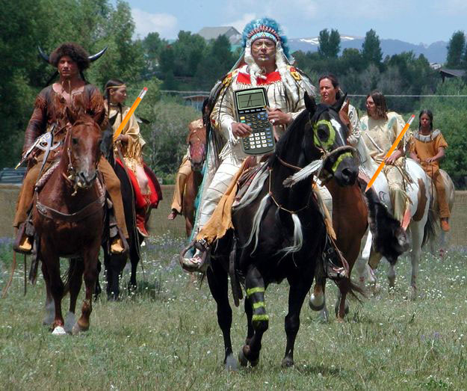

I finally made it back to the campsite after dusk, and I was tired and frustrated. Thankfully, the rest of the jamboree passed without a hitch. To this day, I still remember that tribe and their weird rituals. Maybe one day I will find those teachers, and when I do I will definitely get at least a passing grade.

Photo Credit: AH

