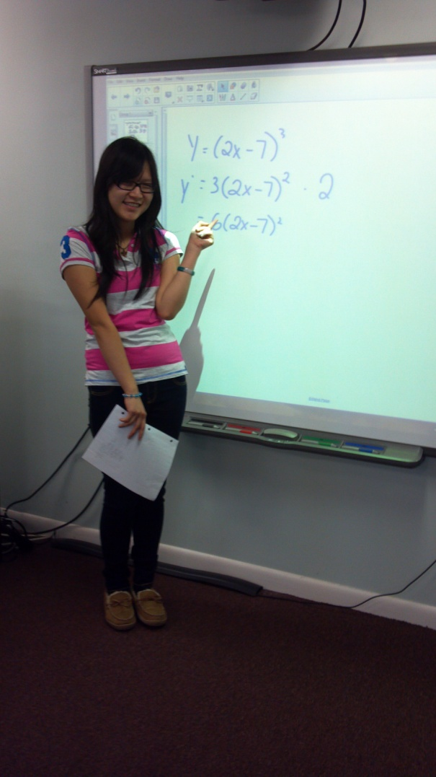
This student explains the concept of the chain rule for finding the derivative of a composite function. Students enjoy any opportunity to illustrate their solutions using the SMART Board.

