Biotechnology Company Research Project
This is a major project in which you will research all aspects of a certain biotechnology company in order to create a poster, portfolio, and presentation. This will allow you to see how science can help you to make real money in the real world. Biotechnology is of value to society and YOU! You will be assigned a real biotechnology company that is making money because of biotechnological discoveries. The poster, portfolio, and presentation will count as your final exam for the spring semester. Your company’s symbol is _______________________________.
Rubric for Portfolio

4 News articles concerning changes in the company’s stock prices…………..5 pts. each
Each article must be summarized and critiqued (all typed, min. one page each)

Rubric for Presentation Points

Name of co………………………………………………………………………………1
Headquarters located…………………………………………………………………..1
Co. description………………………………………….……………………………….2
Co. history……………………………………………….………………………………2
What co. makes………………………………………….……………………………...5
Details of products……………………………………….……………………………..7
How is biotechnology used to make the products…………………………………….6
Who do they sell products to…………………………..……………………………….2
How do they make money……………………………….……………………………..3
When co. founded……………………………………….……………………………...1
How many employees…………………………………….………………………...…..1
No. of employees with degrees………………………….....…………………………..2
Pay for officers and executives…………………………………………………….…..3
Important co. news……………………………………….……………………….……4
Plans for future……………………………………………………………………..…...3
Explain rises and falls in stocks……………………………………………………..…..5

Rubric for Poster Points

Your Name……………………………………………………………….......................1
Name of Company…………………………………………………………..………….1
Stock Symbol………………………………………………………………..……….....1
Headquarters………………………………………………….……………..…………1
Company’s Business profile…………………………………….…………..………….8
Co. description
Market cap
Co. p/e ratio
Shares out
Beginning stock price
Ending stock price
52 week high
52 week low
Graph of stock performance (by hand)…………………………………………………20

How to Plot the Points on the Graph
- Construct your graph to look like this:
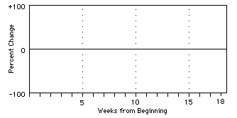
- Calculation of values. Because it is difficult to compare stocks that have different price profiles, the prices must be "normalized" (they should be made relative to their starting price). Use this formula to determine the percent change of the stock:
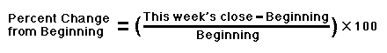
- Here is a graph that has points for the first half of a semester: 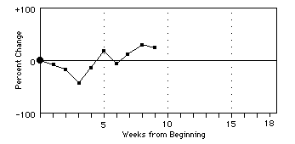
- Your final poster should have a format something like this:
