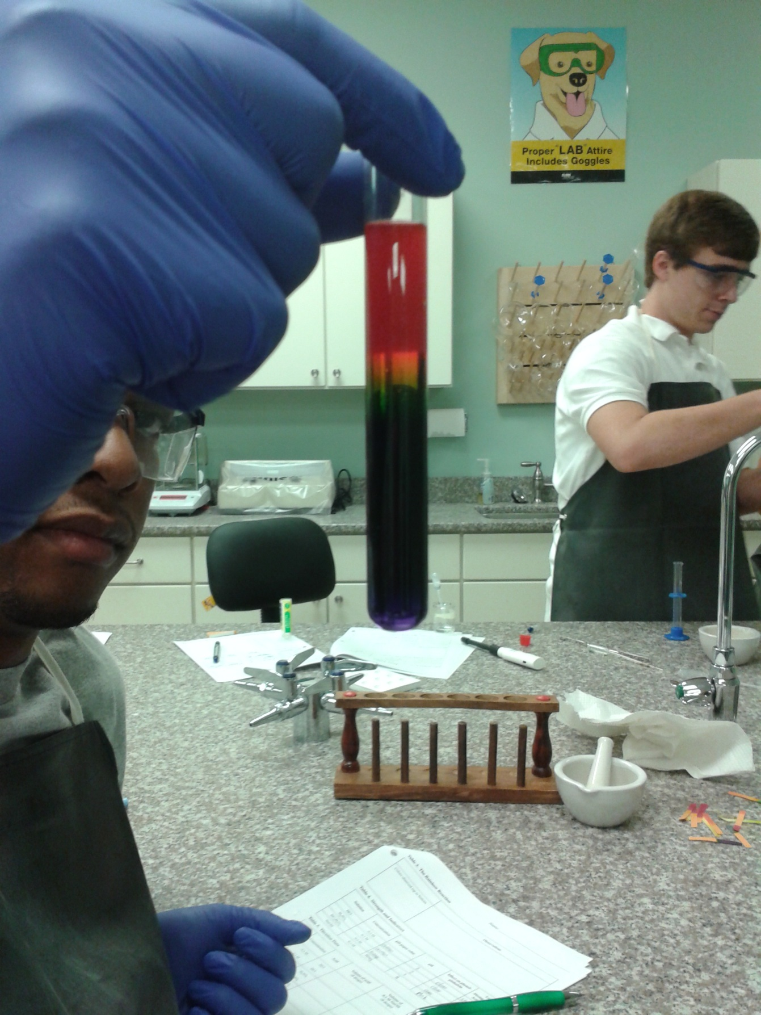

*The students made a rainbow in a test tube by adding hydrochloric acid and saturated sodium bicarbonate along with a universal pH indicator. The heavier base sank to the bottom and the lighter acid rose to the top and as they combined with the pH indicator, the colors of the rainbow were produced.*