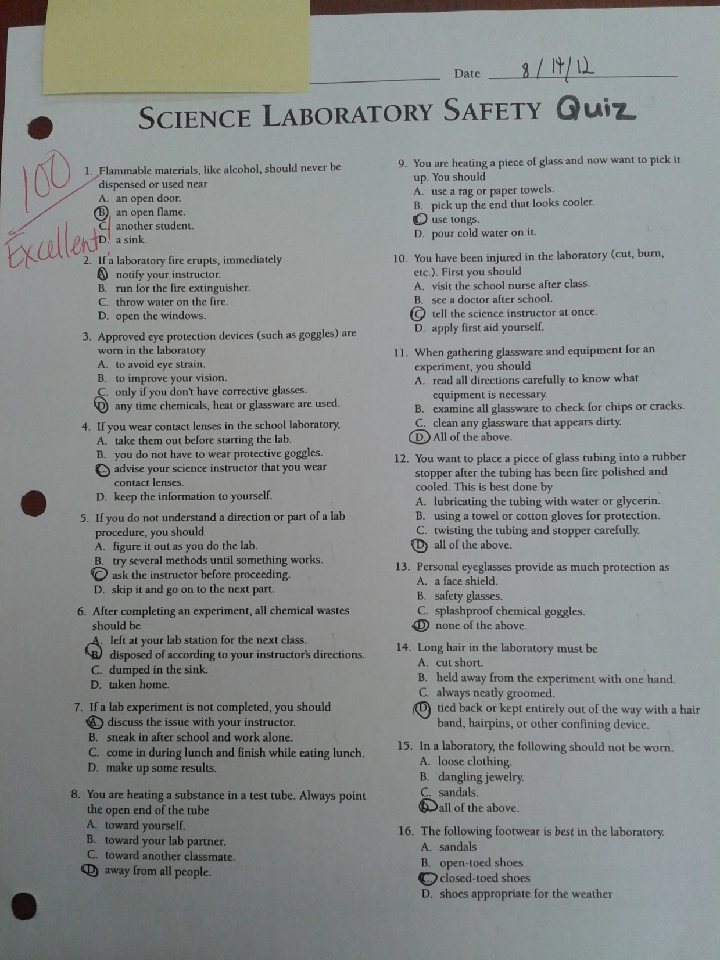

*Lab rules are established before the students conduct experiments. Lab safety is very important and all rules must be followed in order to have a safe and productive learning experience. The picture shows a student’s safety quiz and their score earned. The safety quiz was an assignment on the second day of class.*