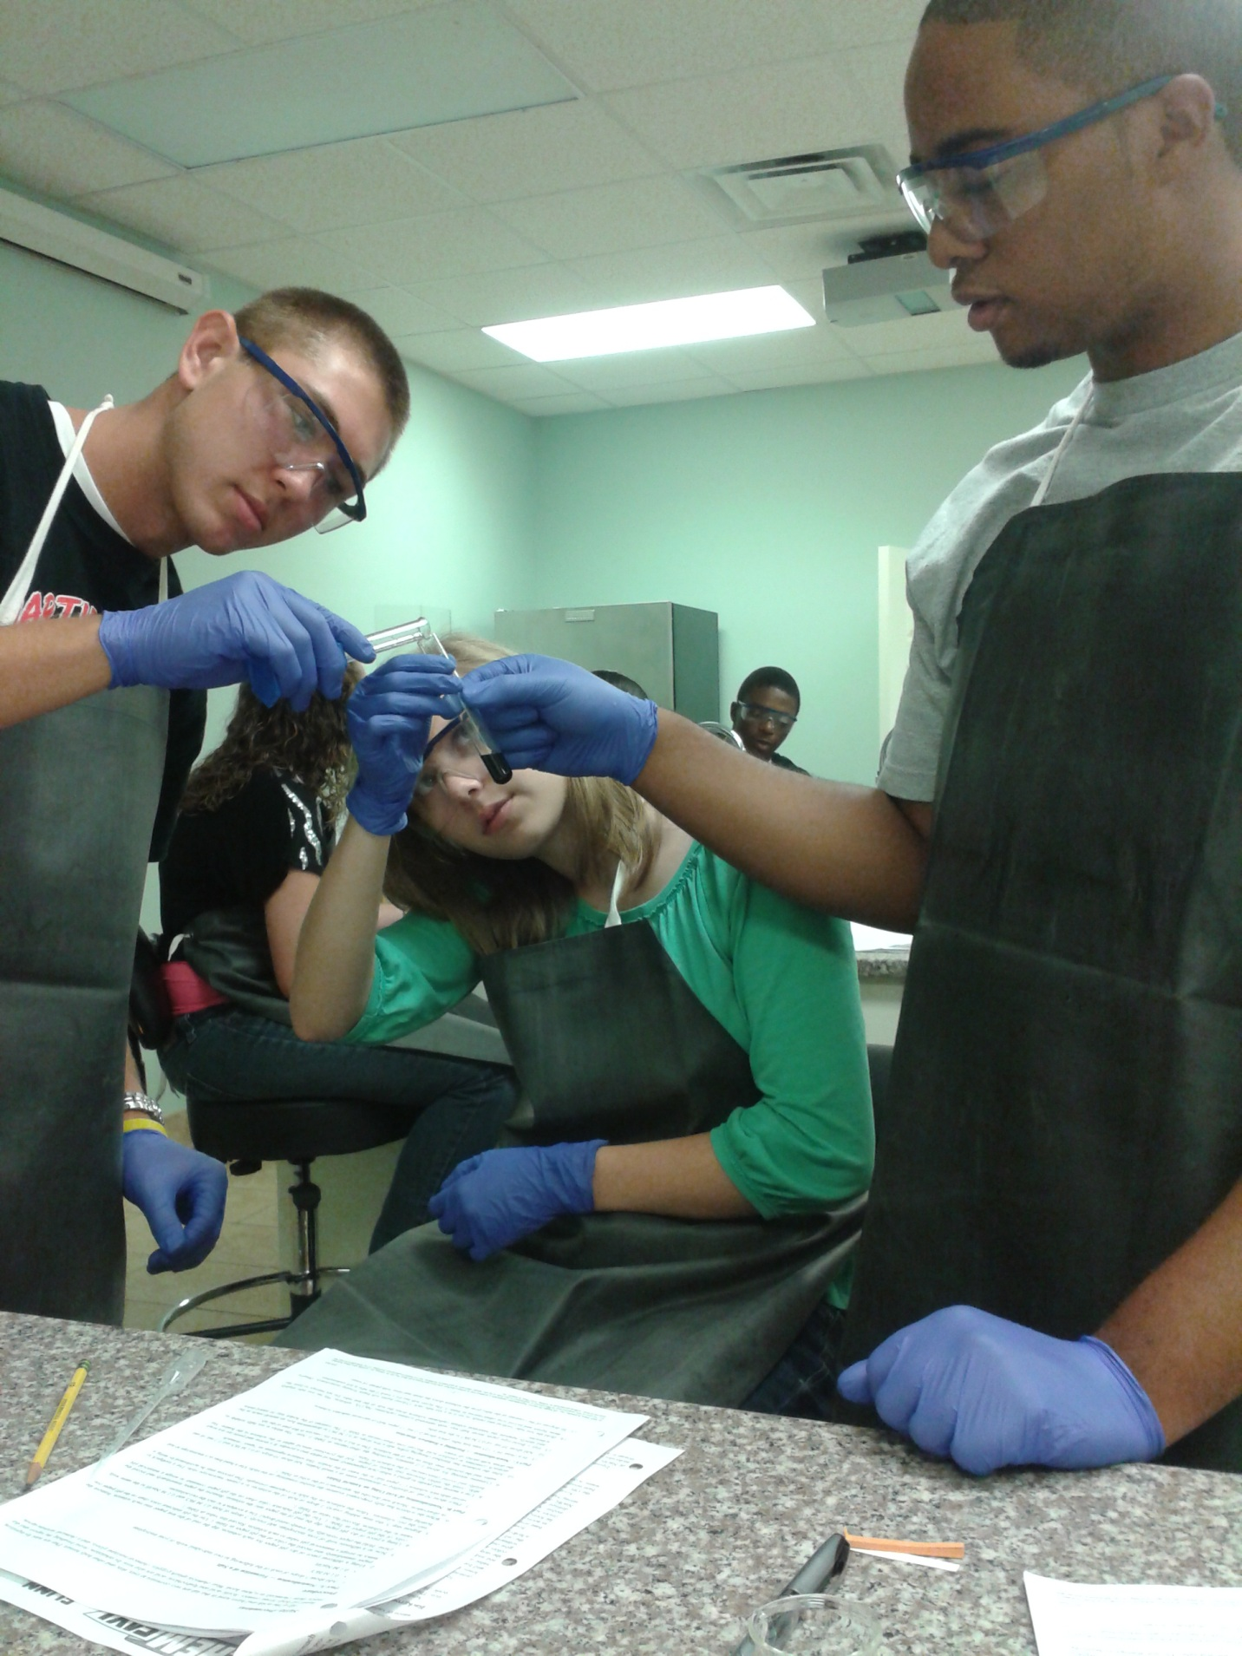

# Students following the lab safety rules.

This picture is evidence of the students following the lab safety rule that I established.